Casey Gray
ITEC 4365
March 11, 2025
Program 3

- Using Selenium to Test User Interactions (page 40)
- functional_tests.py (page 41)
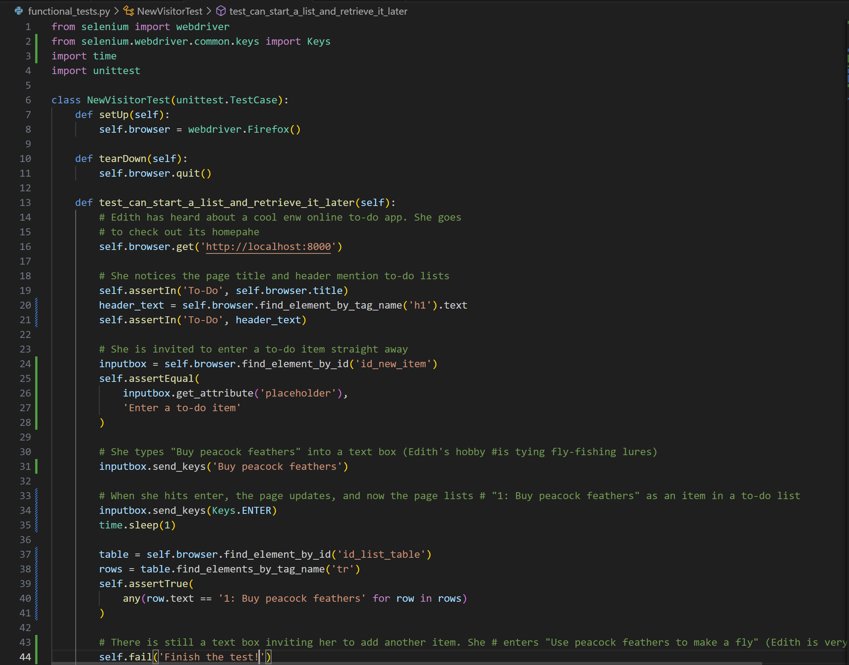

- $ python functional_tests.py (page 42)
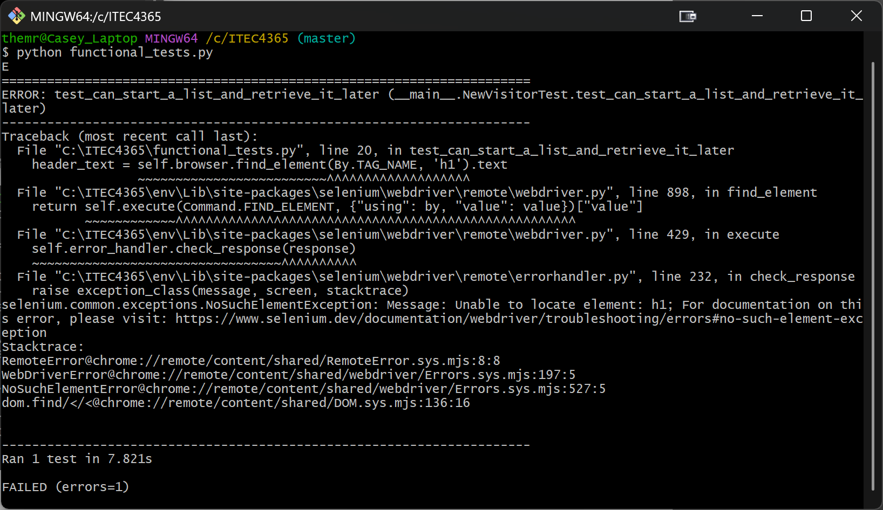
- Refactoring to Use a Template $ python manage.py test (page 43)
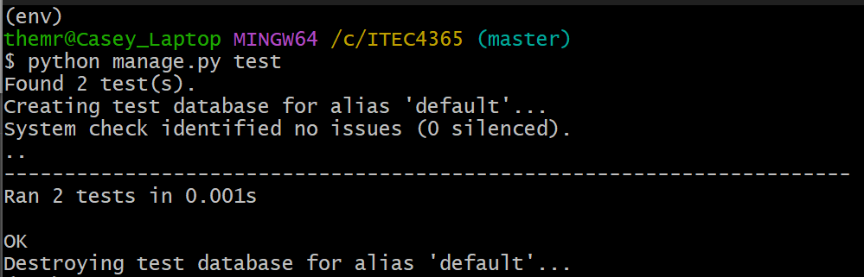

- Create a directory called lists/templates (page 44)
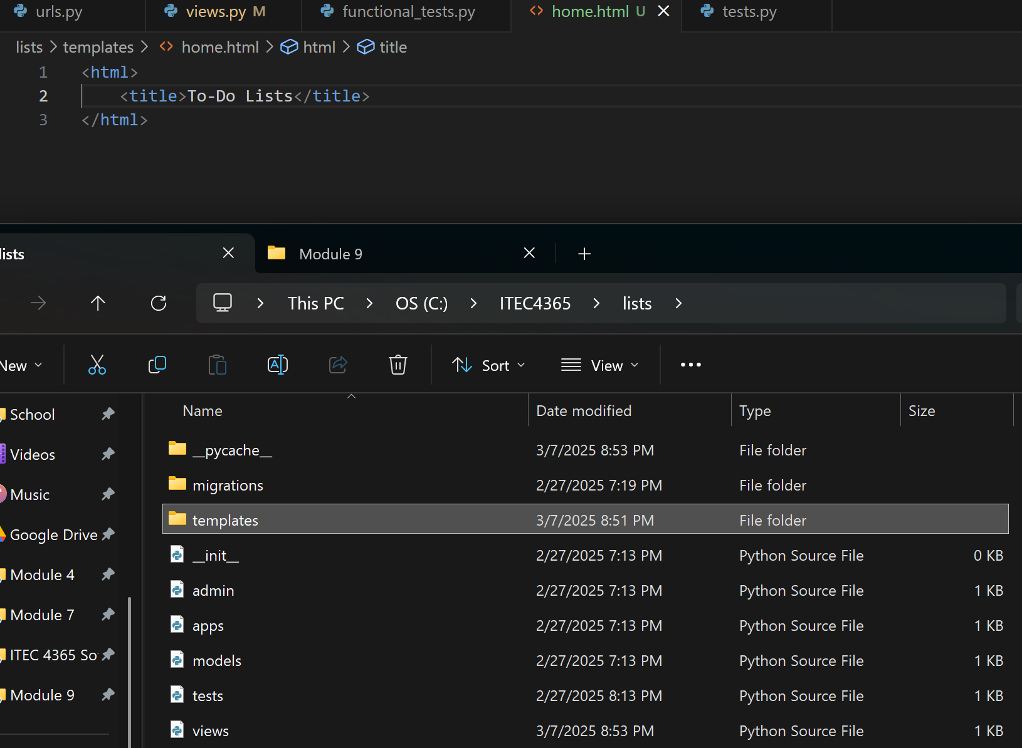
- $ python manage.py test (page 45)
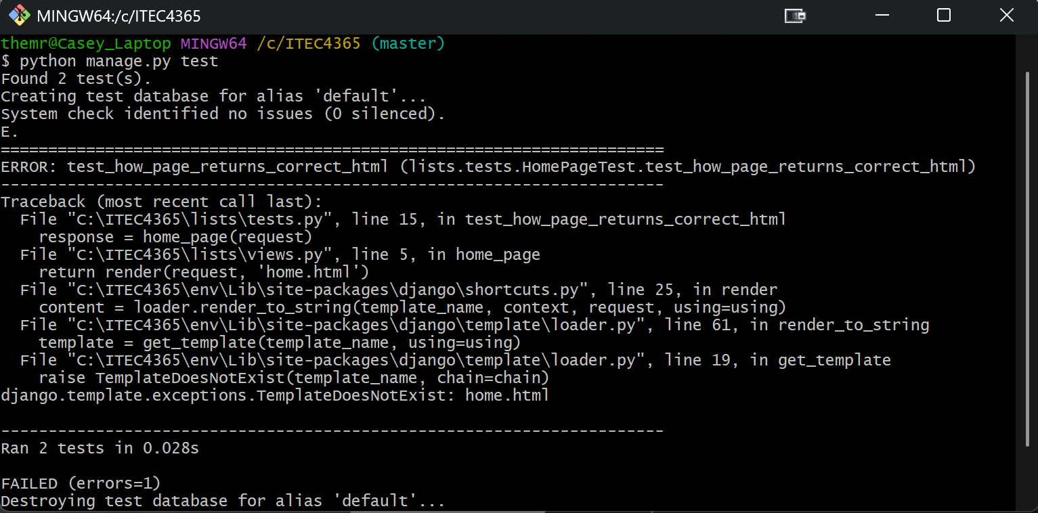
- superlists/settings.py (page 46)
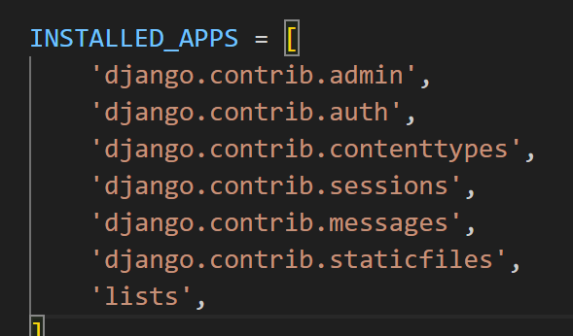
- $ python manage.py test (page 46)
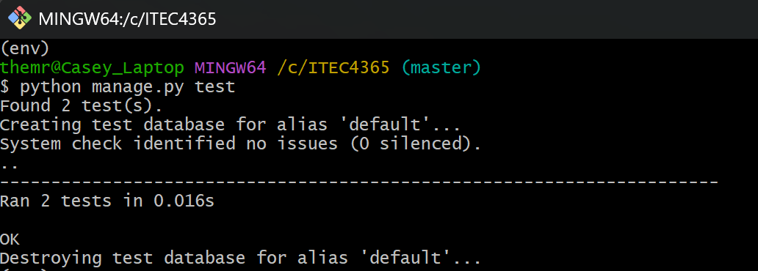
- Git
